YOUR JOURNAL

Each week you should make sure your journal is completed. It should contain the following:

Background reading and research
Comments on how the week has gone
Planning for next week
Sketches
Photos
Diagrams
Data gathered
Safety issues
Graphics
Work done during the week
Videos
JOURNAL

GRAPHICS
“A picture is worth a thousand words.” (Fred Barnard, 1921)

Graphics are a vital part of any scientific research. They come in many formats:

- Quick labeled sketches with notes are generally the type of graphic used in a journal. They can remind you of how equipment was used for future reference.
- A photo can give a clear idea of how equipment is being used.
- Videos can be very useful in recording certain experiments, or may be used to accurately measure fast moving objects. Some scientists are now recording their work to put on the internet for other scientists to see and collaborate with them.

WORK DONE DURING THE WEEK.
At the very least this should be an outline of the work you have done, week by week. It serves mainly as a reminder to you about the details of your work. So it needs to have enough detail to be useful but not so much that it takes ages to write down – a careful balance is needed that will come with experience.

- METHOD. You should note all relevant details of what you did in your investigation to the extent that you could use your notes to accurately repeat your investigation it you needed to. Sketches and diagrams are very useful in this section.
- DATA. This part of your weekly journal should contain ALL and ANY data you have collected during the week. The data should be recorded in tables with all units and quantities clearly recorded. No data should be left out however insignificant you may think it is – you never know. Having it recorded may save you having to repeat that part of your project! Graphs are an important part of your data – sketches of relevant graphs should go into your journal.
- SAFETY. You will need to fill in risk assessment sheets for all experiments you do. Even professional scientists have to do this in research laboratories.
- ASSESSMENT. You should comment on your assessment of how you think your work has gone – where there any problems, did something not work, are you suspicious of some of your results, did you get through all the work you intended to?

PLANNING FOR NEXT WEEK
Use the assessment of the week to make some plans for next week. Maybe you need to repeat something, perhaps you have got some new ideas to follow up as a result of this week’s work. Maybe you are right on schedule and know exactly what you had intended to be doing next week – great – go for it!

BACKGROUND READING
As you work through your research project you will come across things you are not sure about or don’t understand or would like to know more about.
You are expected to do a certain amount of reading research for your project as well as practical research. You should always make a record (reference) of any reading you do, as well as a brief summary of what you found out – you may want to know more about this particular thing later on in your project.

SAMPLE PAGES FROM A JOURNAL
How you record all this is up to you – there are many different ways of doing it.
The next two pages show a suggested format with my comments attached.

These students were researching into the cost effectiveness of some AA batteries they had purchased at Woolworths – this is their journal for the week.

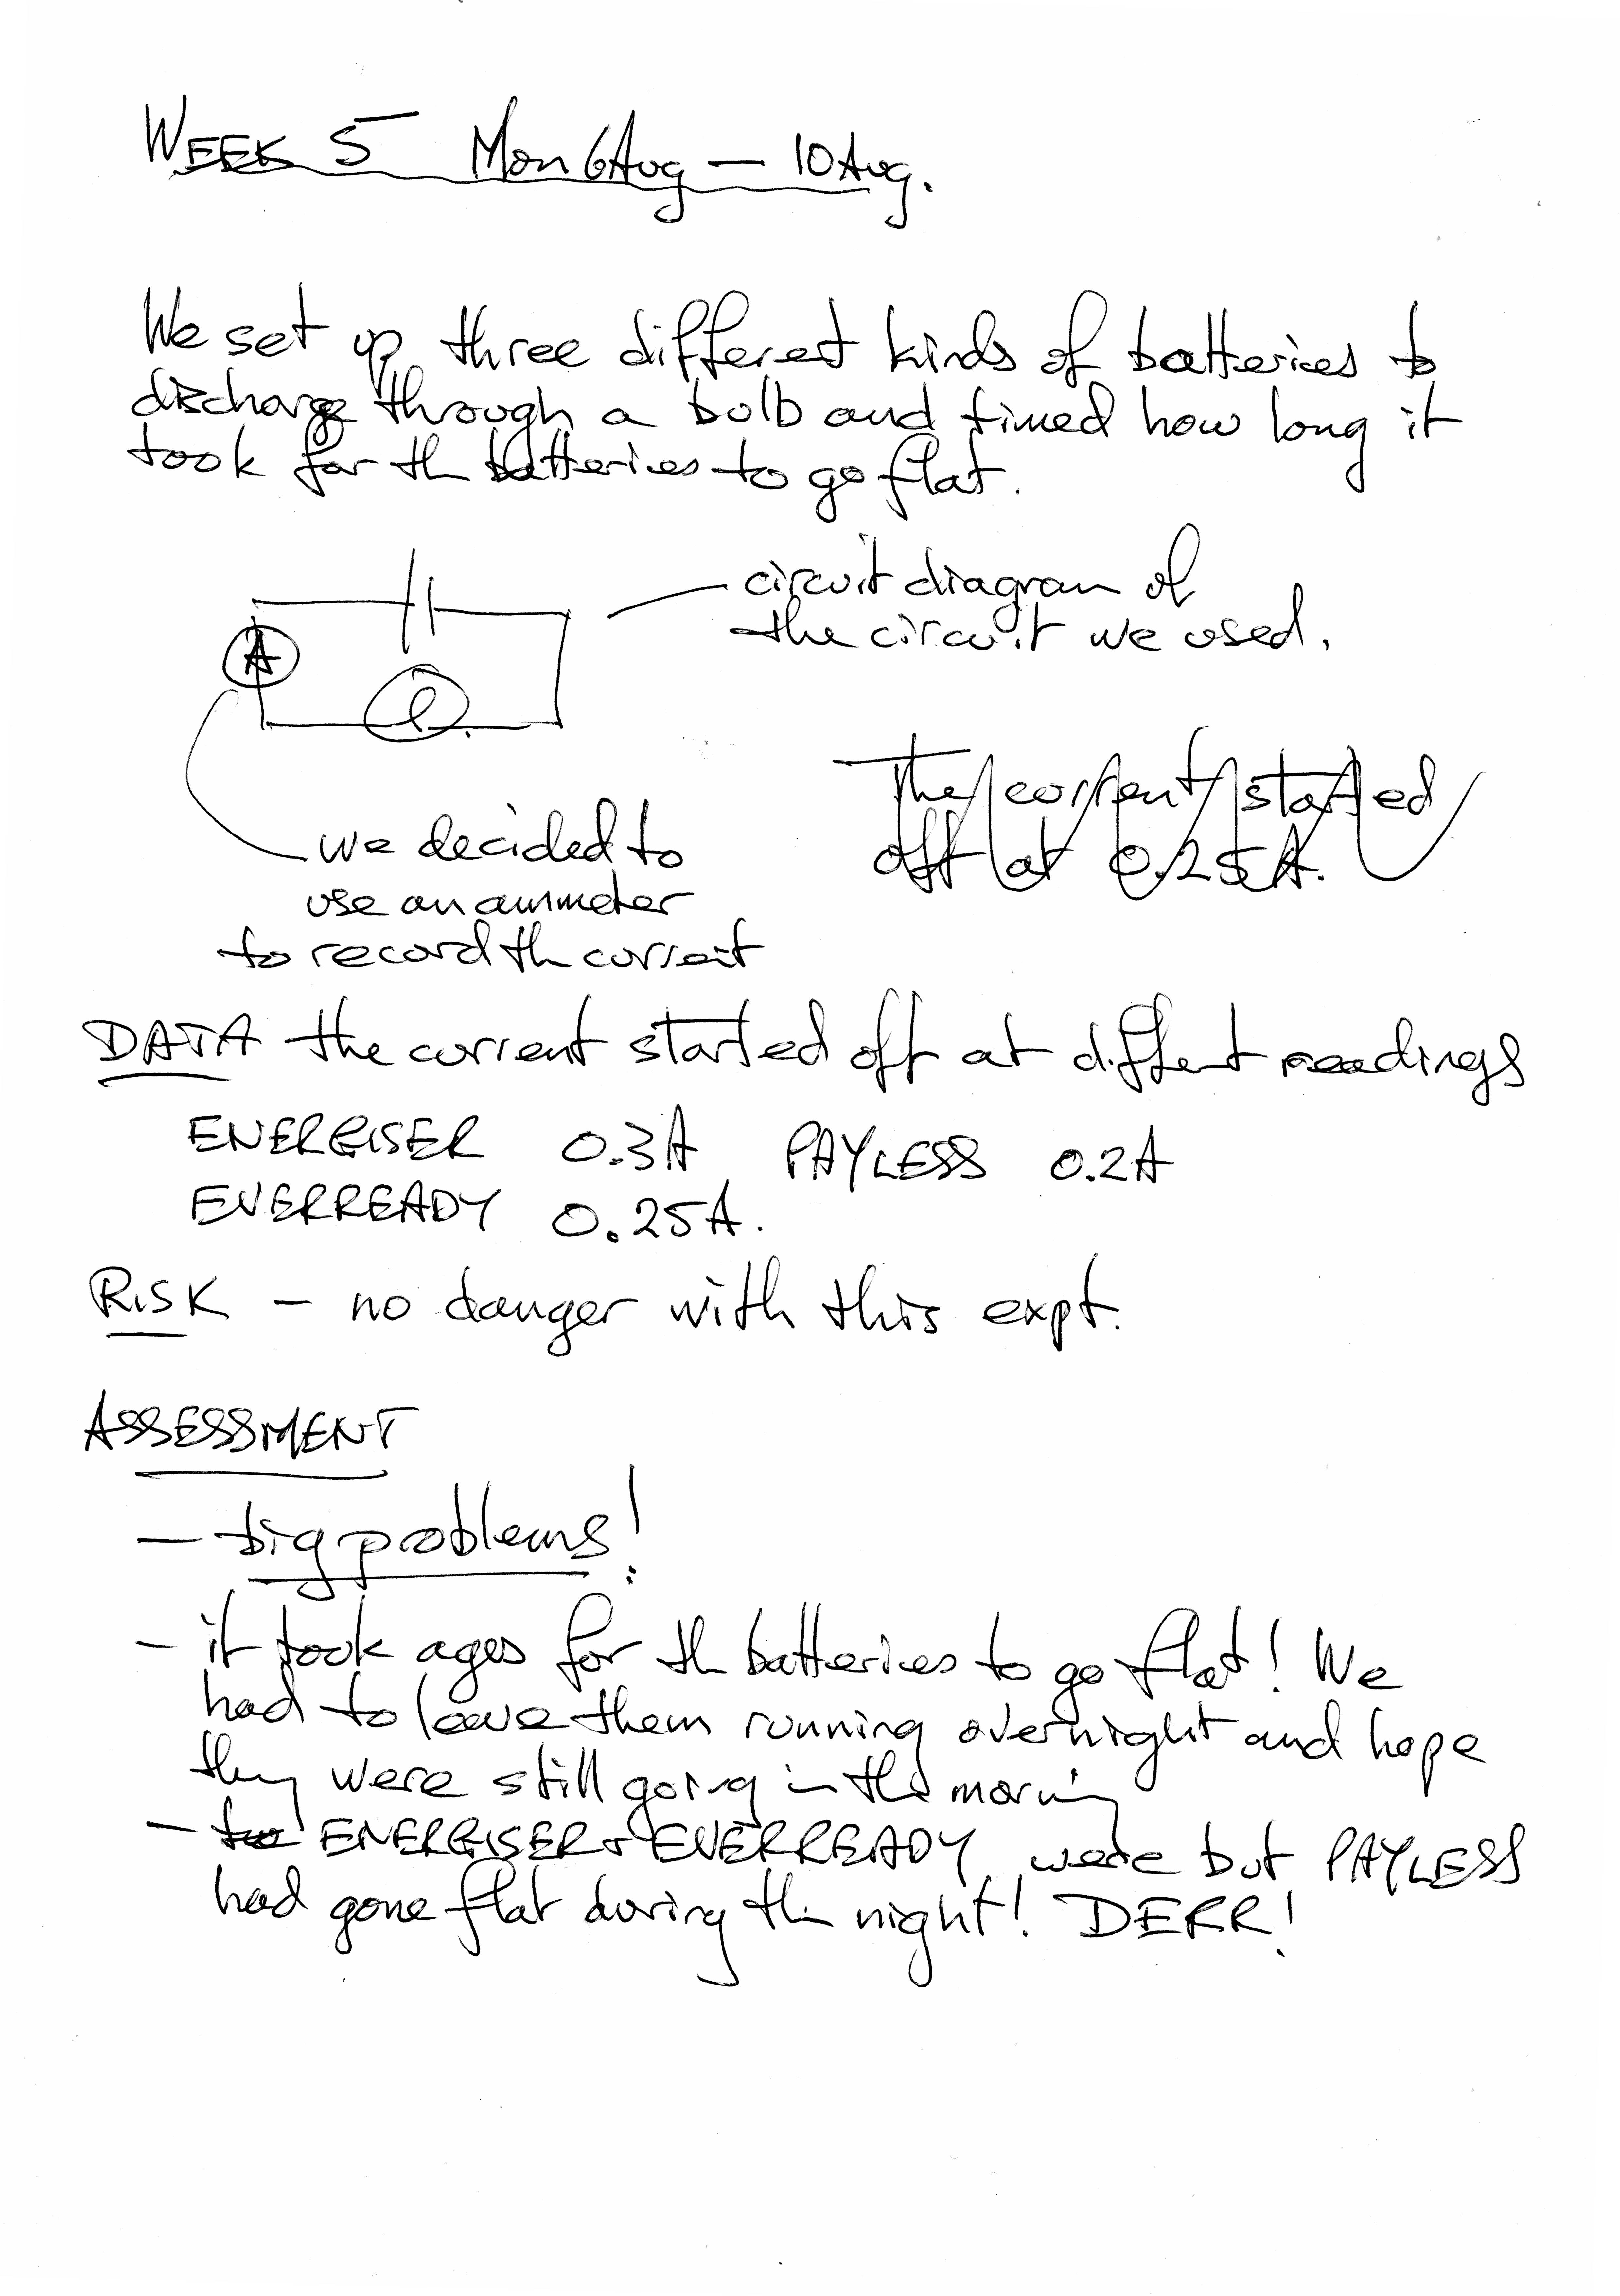
Notes on what was done during the week – more detail is needed in a journal for an EEI
A journal does not have to be as neat as a final write up. However it does need to make sense and be legible.
Make use of diagrams and sketches wherever you can
Data has been recorded – good. However I would have expected a table rather than this kind of layout
Critique of how the work went.
Don’t be afraid to be honest about how things are going. Look for answers to problems.
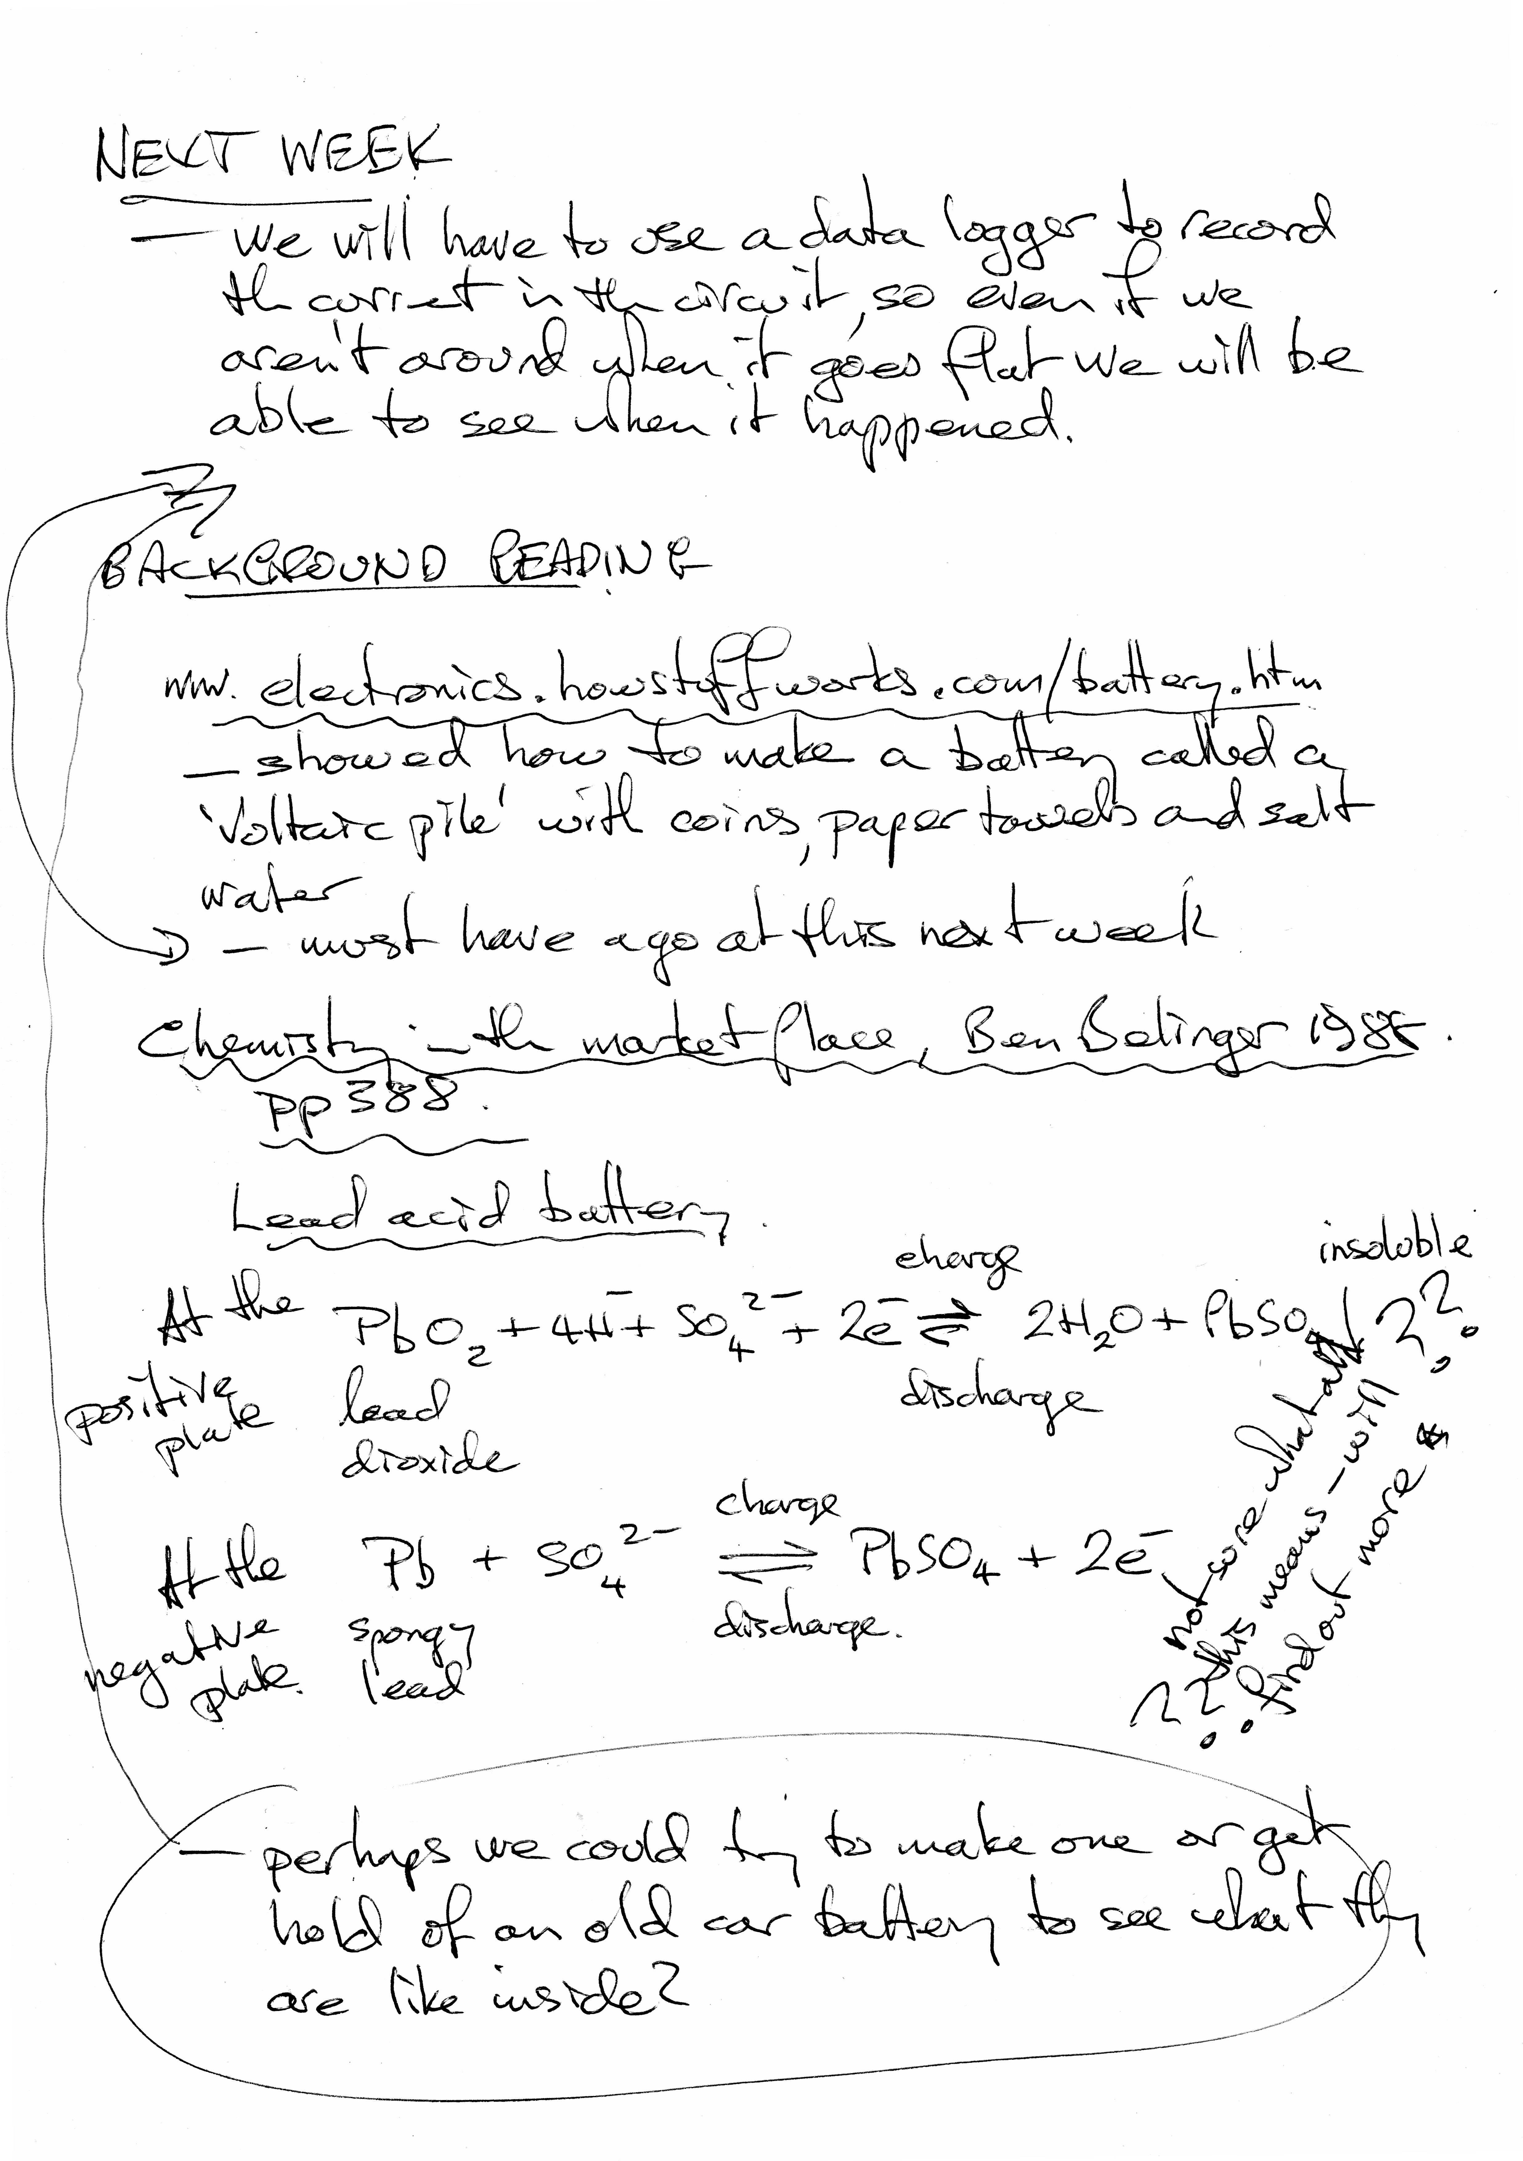
Plans for next week’s work. This may need to be modified as you go. That’s OK, but don’t forget to note any changes of direction or new thoughts about what needs to be done.
You are expected to do your own ‘background reading’ about your research. You should outline this in your journal together with references for your sources.
Appropriate symbols and terminology being used.
Good!

