The Thermistor

A thermistor is a bipolar* semiconductor circuit element. It is in effect a temperature dependent resistor.
*contacts can be connected + - or - +
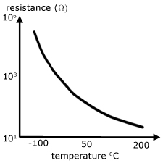
The arrangement below is called a potential divider. The p.d.'s V_{R} and V_{T} are in the ratio of the resistors they appear across.
When the thermistor is hot its resistance is low and of the order of 100's of ohms. In this case, most of the 5V p.d. falls across the 10kΩ resistor. As the temperature decreases, the resistance of the thermistor increases. When its resistance reaches 10kΩ the p.d. is shared equallybetween it and the series resistor. At really cold temperatures the resistance increases to the order of MΩ's, when most of the p.d. falls across it and not the series resistor.
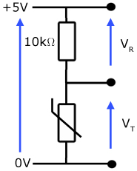

The Light Dependent Resistor (LDR)

Like the thermistor, the LDR is also a bipolar semiconductor circuit element. LDR's are made from high resistance semiconductor material, whose resistance decreases with increasing incident light intensity.
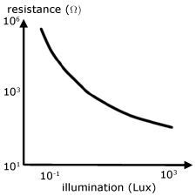
Typically effect of light on a LDR is to reduce its resistance from ~ 10⁶ Ω to ~ 10² Ω.
The arrangement below is called a potential divider. The p.d.'s V_{R} and V_{LDR} are in the ratio of the resistors they appear across.
In the dark, the resistance of the LDR is of the order of MΩ's. So most of the 5V p.d. falls across it and not the series resistor. With more illumination, the resistance of the LDR decreases. When it reaches 10kΩ the p.d. is shared equally with the series resistor. In bright light, its resistance is of the order of 100's of Ω's. Then, most of the p.d. falls across the series resistor.
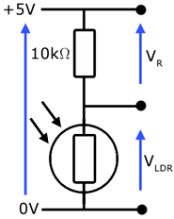

Light Emitting Diode (LED)

An LED is essentially a modified junction diode (or p-n diode) so that it gives out light when current flows through it.
Junction diodes are made from two types of semiconductor material, which have been 'doped' to alter their properties.
p-type: rich in charge carriers called 'holes' (missing electrons)
n-type: rich in free electrons
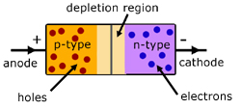
The two types of semiconductor meet in the middle at what is called the p-n junction. Here, with no p.d. applied, the holes from the p-type meet up with the free electrons from the n-type and cancel each other out.
However, when a p.d. is applied, with n-type '-' and p-type '+' (called forward biased), a current flows. This current is made up of free electrons moving across to the '+' terminal and holes moving towards the '-' terminal.
When the polarity is reversed(reverse bias), with n-type made '+' and p-type made '-' , no current flows. So we have a device that only allows current to flow in one direction.

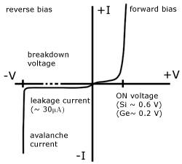

On a V-I graph the top right quadrant shows how a very small forward p.d. causes the diode to conduct. Notice the high current for a small p.d. increase.
The bottom left quadrant shows what happens when the diode is reverse biased ('+' contact connected to '-' supply and vice versa). Notice for increasing p.d. there is a constant 'leakage current' . This is very small, being of the order of micro-amps. There comes a point when the p.d. is so high that 'breakdown' occurs. A large current passes and the diode is destroyed.
it is essential in LED circuits that the exact p.d. falls across the device. If the p.d. is too high the LED will allow too much current to flow through it. The result will be overheating and failure.
To avoid this, an LED always has a 'limiting resistor' placed in series to limit the current. The level of current designed for is just enough to trigger light from the device.

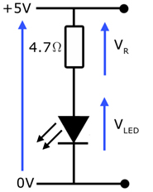

Example: Find the limiting resistor for an LED, where:
i) the max. LED current required is 100mA
ii) the forward LED voltage is 0.65V
iii)the supply p.d. is 5V

If 0.65V falls across the LED, then 4.35V must fall across the limiting resistor.
The current through both the LED and the limiting resistor is 100mA.
Therefore the limiting resistance R is given by R = V/I .
R = 4.35/0.1 = 43.5 Ω
The closest commercial resistor value is 47 Ω

POTENTIAL DIVIDERS

What are they - they can be used to split the voltage of a circuit. They are widely used in electronic circuits for setting and adjusting voltages - e.g. in radios, games and toys. You may find that you need a supply of 6 volts and you have a 9 volt battery, your only option may be to make a potential divider.
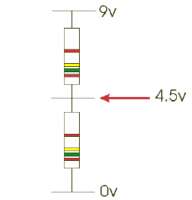 |  | When two resistors of equal value (e.g. 1K) are connected across a supply, current will flow through them. If a meter is placed across the supply shown in the diagram it will register 9v. If the meter is then placed between the 0v and the middle of the two resistors it will read 4.5v. The battery voltage has been divided in half.
If the resistor values are changed to 2K and 1K the voltage will be 6v. The voltage at the centre is determined by the ratio of the two resistor values and is given by the formula:  V = supply voltage x R₂/R₁+R₂  _{V= 9v x 2000}  ₁₀₀₀₊₂₀₀₀  v = 9v x (2000/3000 ohms)  V = 9v x 0.6666666 ohms  V = 6v |  | 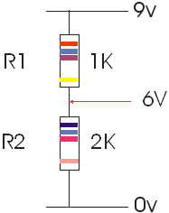
An alternative way to work out the answer is to:  1. Add both resistors together.  2. Divide the voltage by the sum of both resistors.  3. Take the largest resistor and multiply it by the answer found in stage two. |  |  | 1K + 2K = 3K  9v/3k (is the same as 9/3) = 3  2k x 3 = 6v
POTENTIAL DIVIDERS - FURTHER QUESTIONS

1. If R1 is 250K and R2 is 500K what is the voltage at ‘A’.
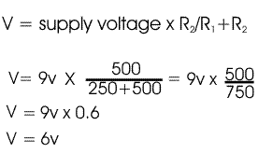
2. If R1 is 600K and R2 is 300K what is the voltage at ‘A’.
3. If R1 is 50R and R2 is 250R what is the voltage at ‘A’.
4. If R1 is 100R and R2 is 300K what is the voltage at ‘A’. (Be careful ! convert 300K into ohms first)
5. If R1 is 10K and R2 is 80K what is the voltage at ‘A’.

