Introduction to Electronics
Electrical energy is the presence and flow of an electric charge. For electrical energy to be produced in a circuit, the circuit must be a _________________.
Current (I)
Electric current is the flow of _____________.
The unit of electric current is the ampere or amp (A). One ampere of electric current is a flow of charge of 1 coulomb per second or 6.25 x 10¹⁸ electrons per second. In most electric circuits, microamps (μA) or milliamps (mA) are used.
Electric current is measured with an ________________.
A ________________ is a material that allows current to flow through it easily. Eg. Copper wire.
Voltage (V)
In order for current to flow through a circuit, there must be a ________________ between different parts of the circuit. A ___________ or _____________ produces a potential difference which causes electrons to flow from the negative pole to the positive pole of the battery.
Potential difference is measured in ___________ and is measured by a ______________.
Potential difference is often referred to as voltage or electromagnetic force (EMF).
Resistance (R)
The flow of electrons is also determined by the resistance of the circuit. Materials that act in opposition to the flow of electrons are known as ___________. Resistance is measured in ___________. Wires in a circuit may act as a form of resistance.
Ohm’s Law
The relationship between current, voltage and resistance in a circuit is known as Ohm’s Law.
The current flowing through a conductor is directly proportional to the potential difference applied across its ends, provided temperature and all physical conditions remain constant.

V = IR
V = I R

Example. If the potential difference of a circuit is 6V and the total resistance of the circuit is 12Ω, what is the current flow through the circuit?

battery ammeter closed loop cell volts ohms voltmeter conductor electrons resistors potential difference

Circuits
The parts that make up a circuit are called components. Circuit diagrams are a shorthand way of showing how components are connected.
Series circuits
(Only one possible route for electron flow)
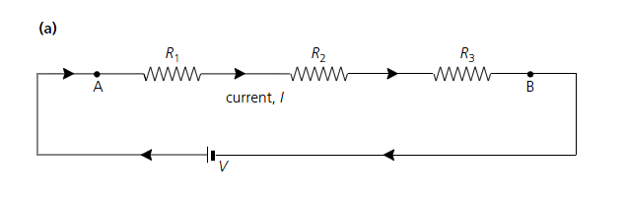
Resistors in series
R_{tot} = R₁ + R₂ + R₃ + ......

Parallel circuits
(More than one route for electron flow)
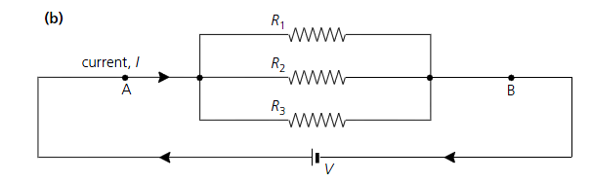
Resistors in parallel
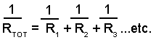

(Note: Although it is now known that electron flow in a circuit is from the negative to the positive pole of a battery, the current is traditionally depicted in circuit diagrams as flowing from the positive to the negative pole (conventional current). )

