General Feedback on Fuels ERT
- Try to refer to the context of chemical’s usage as a fuel wherever relevant. What does it matter if it has a RON of 106? If ethanol is polar but petrol isn’t? If octane has higher or lower energy than ethanol? What does that mean in terms of the fuel being good or bad in an engine?

- ANSWER THE QUESTION! Be selective about what you put in and what you leave out! Good idea to put in data tables early and use that to direct your discussion about chemical properties of your fuel. Remember that I gave you some in the stimulus material. Some of you are getting carried away with production and not talking about the chemical properties of the fuel which is the point of the assignment.

- Format your equations, formulae and units correctly throughout report.
  - i.e. not C8H18 but C₈H₁₈ . To do this you can highlight numbers and use CTRL and = or if using Word 2007 there is an x₂ button in toolbar.
  - Ensure your equations look ok and are balanced. Use Equation Editor if needed to help format, although you can do it quite well using Insert Symbol for →
  - Name states in equations (gas, solid, liquid etc.)
  - Equations should be referred to in text, not just appear without explanation. This can be as simple as “The combustion of diesel is given by: ...” and then the equation. Or you can draw attention to a product or quantities by “Note the formation of CO₂ in the combustion of diesel,” or “Note that 7 times as many oxygen molecules as octane molecules are required in the combustion of petrol. This means that...”
  - Write 35°C not 35 degrees celsius.

- Name and number your tables and figures and ensure you refer to them in the text.

“As demonstrated in Figure 1 below, octane (petrol) is a long hydrocarbon chain, while ethanol is a short-chain alkane with a hydroxyl group, making ethanol a polar molecule and miscible in water. Ethanol’s attraction to water can cause problems as a fuel because....”
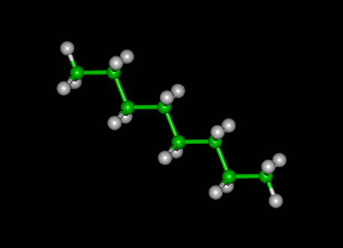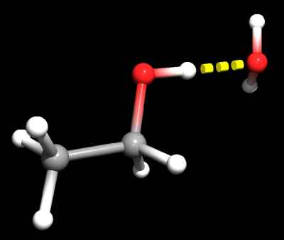
Figure 1: (LEFT) Octane molecule is long, straight and non-polar, while (RIGHT) Ethanol molecule is short and polar, hence its attraction to water via hydrogen bonding.

- Acknowledge sources, especially when giving a definition or quoting some data. Don’t over-use explanations from others – what do YOU know? I am checking each with internet plagiarism search technique. You can use in-text referencing or footnotes or endnotes but use something!

